MID term Exam Question bank

Topic 1: Class
- INPUT
#include <iostream>
using namespace std;
class Student {
public:
string name;
int rollNo;
float marks;
void accept() {
cout << "Enter student name: ";
cin >> name;
cout << "Enter roll number: ";
cin >> rollNo;

cout << "Enter marks: ";
cin >> marks;
}
void display() {
cout << "\n--- Student Details ---" << endl;
cout << "Name: " << name << endl;
cout << "Roll No: " << rollNo << endl;
cout << "Marks: " << marks << endl;
}
};

int main() {
Student s1;
s1.accept();
s1.display();
return 0;
}
- OUTPUT
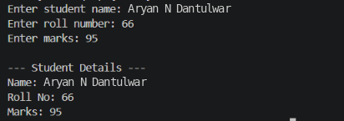

- INPUT

#include <iostream>
using namespace std;
class Rectangle {
public:
float length;
float breadth;
void accept() {
cout << "Enter length of the rectangle: ";
cin >> length;
cout << "Enter breadth of the rectangle: ";
cin >> breadth;
}
void displayArea() {
float area = length * breadth;
cout << "\n--- Rectangle Details ---" << endl;
cout << "Length : " << length << endl;
cout << "Breadth: " << breadth << endl;
cout << "Area : " << area << endl;
}
};

int main() {
Rectangle rect;
rect.accept();
rect.displayArea();

return 0;
}

- OUTPUT
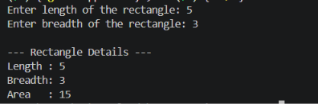

3. INPUT
#include <iostream>
Using namespace std;
class Book {
public:
int bookId;
string title;
string author;
float price;
void accept() {
cout << "Enter Book ID: ";
cin >> bookId;
cout << "Enter Book Title: ";
cin >> title;
cout << "Enter Author Name: ";
cin<<author;
cout << "Enter Price: ";
cin >> price;
}
void display() {
cout << "\n--- Book Details ---" << endl;
cout << "Book ID : " << bookId << endl;
cout << "Title : " << title << endl;
cout << "Author : " << author << endl;
cout << "Price : $" << price << endl;
}
};

int main() {
Book myBook;
myBook.accept();
myBook.display();
return 0; }
- OUTPUT
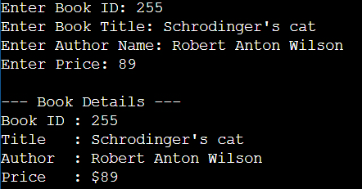

Topic 2: Object

4. INPUT
#include <iostream>
using namespace std;
class Distance {
public:
int totalMeters;
void accept() {
cout << "Enter distance in meters: ";
cin >> totalMeters;
}
void convertAndDisplay() {
int kilometers = totalMeters / 1000;
int remainingMeters = totalMeters % 1000;
cout << "\n--- Distance Conversion ---" << endl;
cout << "Total Input : " << totalMeters << " meters" << endl;
cout << "Converted : " << kilometers << " km and " << remainingMeters << " meters" << endl;
}
};
int main() {
Distance d;
d.accept();
d.convertAndDisplay();
return 0;
}

- OUTPUT
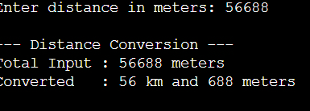
5.INPUT

#include <iostream>
using namespace std;
class Product {
public:
string productName;
int quantity;
float pricePerUnit;
void accept() {
cout << "Enter product name: ";
cin >> productName;
cout << "Enter quantity: ";
cin >> quantity;
cout << "Enter price per unit: ";
cin >> pricePerUnit;
}
void displayTotalCost() {
float totalCost = quantity * pricePerUnit;
cout << "\n--- Product Summary ---" << endl;
cout << "Product Name : " << productName << endl;
cout << "Quantity : " << quantity << endl;
cout << "Price per unit : $" << pricePerUnit << endl;
cout << "-----------------------" << endl;
cout << "Total Cost : $" << totalCost << endl;
}
};
int main() {
Product item;
item.accept();
item.displayTotalCost();
return 0;
}
- OUTPUT
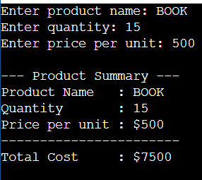
6.INPUT
#include <iostream>
using namespace std;
class Time {
public:
int hours;
int minutes;
int seconds;
void accept() {
cout << "Enter hours: ";
cin >> hours;
cout << "Enter minutes: ";
cin >> minutes;
cout << "Enter seconds: ";
cin >> seconds;
}
void display() {
cout << "\n--- Time ---" << endl;
cout << hours << ":" << minutes << ":" << seconds << endl;
}
};
int main() {
Time t;
t.accept();
t.display();
return 0;
}
- OUTPUT
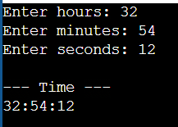

Topic 3: cout <<
- INPUT
#include <iostream>
using namespace std;

int main() {
string name = "Aryan N Dantulwar";
int age = 18;
string department = "Computer Science";
string collegeName =”MIT ADT University”;

cout << "Name : " << name << endl;
cout << "Age : " << age << endl;
cout << "Department : " << department << endl;
cout << "College Name: " << collegeName << endl;

return 0;}
- OUTPUT
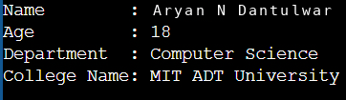
- INPUT
#include <iostream>
using namespace std;
int main() {
int num;
cout << "Enter a number: ";
cin >> num;
cout << "\n--- Multiplication Table of " << num << " ---" << endl;
for (int i = 1; i <= 10; i++) {
cout << num << " x " << i << " = " << (num * i) << endl;
}

return 0;
}
- OUTPUT
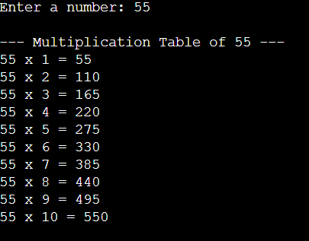
9.INPUT
#include <iostream>
using namespace std;
int main() {
double num1, num2;
cout << "Enter first number: ";
cin >> num1;
cout << "Enter second number: ";
cin >> num2;
cout << "\n--- Results ---" << endl;
cout << num1 << " + " << num2 << " = " << (num1 + num2) << endl;
cout << num1 << " - " << num2 << " = " << (num1 - num2) << endl;
cout << num1 << " * " << num2 << " = " << (num1 * num2) << endl;
if (num2 != 0) {
cout << num1 << " / " << num2 << " = " << (num1 / num2) << endl;
} else {
cout << "Division by zero is not allowed." << endl;
}
return 0;
}
- OUTPUT
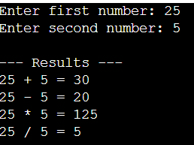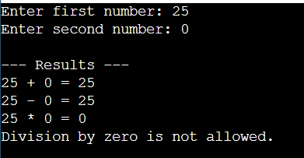

Topic 4: cin >>
10. INPUT
#include <iostream>
using namespace std;
int main() {
string name;
int rollNo;
float marks;
cout << "Enter student name: ";
cin >> name;
cout << "Enter roll number: ";
cin >> rollNo;
cout << "Enter marks: ";
cin >> marks;
cout << "\n--- Student Details Entered ---" << endl;
cout << "Name : " << name << endl;
cout << "Roll No : " << rollNo << endl;
cout << "Marks : " << marks << endl;

return 0;
}
- OUTPUT
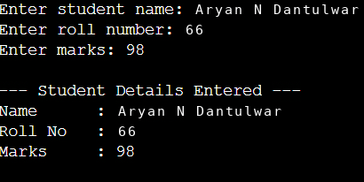
11. INPUT
#include <iostream>
using namespace std;
int main() {
double num;
cout << "Enter a number: ";
cin >> num;
if (num > 0) {
cout << num << " is positive." << endl;
} else if (num < 0) {
cout << num << " is negative." << endl;
} else {
cout << "The number is zero." << endl;
}
return 0;
}
- OUTPUT
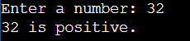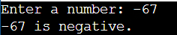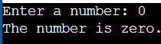
12.INPUT
#include <iostream>
using namespace std;
int main() {
double num1, num2;
cout << "Enter first number: ";
cin >> num1;
cout << "Enter second number: ";
cin >> num2;
cout << "\nBefore swapping:" << endl;
cout << "First number = " << num1 << endl;
cout << "Second number = " << num2 << endl;
double temp = num1;
num1 = num2;
num2 = temp;
cout << "\nAfter swapping:" << endl;
cout << "First number = " << num1 << endl;
cout << "Second number = " << num2 << endl;
return 0;
}
- OUTPUT
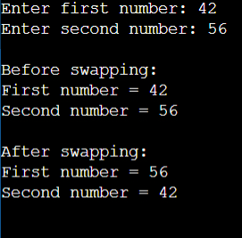

Topic 5: Data Members
13.INPUT
#include <iostream>
using namespace std;
class BankAccount {
public:
string accountNumber;
double balance;
void accept() {
cout << "Enter account number: ";
cin >> accountnumber;
cout << "Enter balance: ";
cin >> balance;
}
void display() {
cout << "\n--- Bank Account Information ---" << endl;
cout << "Account Number : " << accountNumber << endl;
cout << "Balance : $" << balance << endl;
}
};
int main() {
BankAccount account;
account.accept();
account.display();
return 0;
}
- OUTPUT
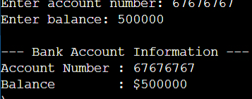
14. INPUT
#include <iostream>
using namespace std;
class Circle {
public:
float radius;
void accept() {
cout << "Enter radius of the circle: ";
cin >> radius;
}
void displayResults() {
float area = 3.14159 * radius * radius;
float circumference = 2 * 3.14159 * radius;
cout << "\n--- Circle Details ---" << endl;
cout << "Radius : " << radius << endl;
cout << "Area : " << area << endl;
cout << "Circumference : " << circumference << endl;
}
};
int main() {
Circle c;
c.accept();
c.displayResults();
return 0;
}
- OUTPUT
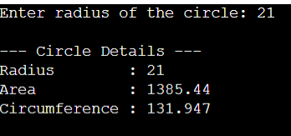

15.INPUT
#include <iostream>
#include <string>
using namespace std;
class Mobile {
public:
string brand;
string model;
float price;
int storage;
void accept() {
cout << "Enter brand: ";
cin >> ws;
getline(cin, brand);
cout << "Enter model: ";
getline(cin, model);
cout << "Enter price: ";
cin >> price;
cout << "Enter storage (in GB): ";
cin >> storage;
}
void display() {
cout << "\n--- Mobile Details ---" << endl;
cout << "Brand : " << brand << endl;
cout << "Model : " << model << endl;
cout << "Price : $" << price << endl;
cout << "Storage : " << storage << " GB" << endl;
}
};
int main() {
Mobile phone;
phone.accept();
phone.display();
return 0;
}
- OUTPUT

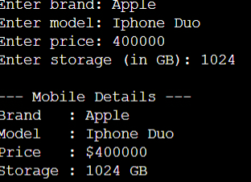

Topic 6: Member Functions
16.INPUT
#include <iostream>
using namespace std;
class Calculator {
public:
double num1;
double num2;
void accept() {
cout << "Enter first number: ";
cin >> num1;
cout << "Enter second number: ";
cin >> num2;
}
void add() {
cout << num1 << " + " << num2 << " = " << (num1 + num2) << endl;
}
void subtract() {
cout << num1 << " - " << num2 << " = " << (num1 - num2) << endl;
}
void multiply() {
cout << num1 << " * " << num2 << " = " << (num1 * num2) << endl;
}
void divide() {
if (num2 != 0) {
cout << num1 << " / " << num2 << " = " << (num1 / num2) << endl;
} else {
cout << "Division by zero is not allowed." << endl;
}
}
};
int main() {
Calculator calc;
calc.accept();
cout << "\n--- Calculator Results ---" << endl;
calc.add();
calc.subtract();
calc.multiply();
calc.divide();
return 0;
}
- OUTPUT
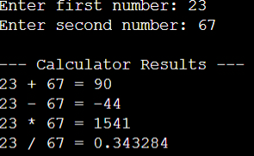
- INPUT
#include <iostream>
using namespace std;
class Rectangle {
public:
float length;
float breadth;
void accept() {
cout << "Enter length: ";
cin >> length;
cout << "Enter breadth: ";
cin >> breadth;
}
void display() {
float area = length * breadth;
float perimeter = 2 * (length + breadth);
cout << "\n--- Rectangle Details ---" << endl;
cout << "Length : " << length << endl;
cout << "Breadth : " << breadth << endl;
cout << "Area : " << area << endl;
cout << "Perimeter : " << perimeter << endl;
}
};
int main() {
Rectangle rect;
rect.accept();
rect.display();
return 0;
}
- OUTPUT
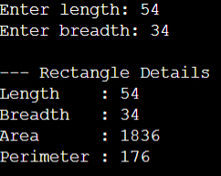
- INPUT
#include <iostream>
#include <string>
using namespace std;
class Student {
public:
string name;
int rollNo;
float marks;
void accept() {
cout << "Enter name: ";
cin >> ws;
getline(cin, name);
cout << "Enter roll number: ";
cin >> rollNo;
cout << "Enter marks: ";
cin >> marks;
}
void display() {
cout << "\n--- Student Details ---" << endl;
cout << "Name : " << name << endl;
cout << "Roll No : " << rollNo << endl;
cout << "Marks : " << marks << endl;
}
};
int main() {
Student s;
s.accept();
s.display();
return 0;
}
- OUTPUT
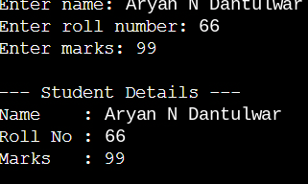

Topic 7: Arrays
- INPUT
#include <iostream>
using namespace std;
class Array {
public:
int arr[10];
void accept() {
cout << "Enter 10 integers:" << endl;
for (int i = 0; i < 10; i++) {
cout << "Element " << (i + 1) << ": ";
cin >> arr[i];
}
}
void display() {
cout << "\n--- Array Elements ---" << endl;
for (int i = 0; i < 10; i++) {
cout << arr[i] << " ";
}
cout << endl;
}
};
int main() {
Array a;
a.accept();
a.display();
return 0;
}
- OUTPUT
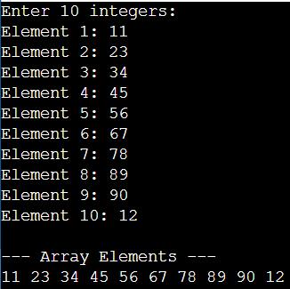
20.INPUT
#include <iostream>
using namespace std;
class SmallestFinder {
public:
int arr[5];
void accept() {
cout << "Enter 5 integers:" << endl;
for (int i = 0; i < 5; i++) {
cout << "Element " << (i + 1) << ": ";
cin >> arr[i];
}
}
void findSmallest() {
int smallest = arr[0];
for (int i = 1; i < 5; i++) {
if (arr[i] < smallest) {
smallest = arr[i];
}
}
cout << "\nThe smallest element is: " << smallest << endl;
}
};
int main() {
SmallestFinder obj;
obj.accept();
obj.findSmallest();
return 0;
}
- OUTPUT
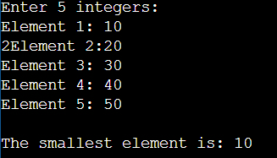

21. #include <iostream>
using namespace std;
class StudentMarks {
public:
float marks[5];
void accept() {
cout << "Enter marks for 5 students:" << endl;
for (int i = 0; i < 5; i++) {
cout << "Student " << (i + 1) << ": ";
cin >> marks[i];
}
}
void calculateAndDisplay() {
float highest = marks[0];
float lowest = marks[0];
float sum = marks[0];
for (int i = 1; i < 5; i++) {
if (marks[i] > highest) {
highest = marks[i];
}
if (marks[i] < lowest) {
lowest = marks[i];
}
sum += marks[i];
}
float average = sum / 5;
cout << "\n--- Marks Summary ---" << endl;
cout << "Highest Marks : " << highest << endl;
cout << "Lowest Marks : " << lowest << endl;
cout << "Average Marks : " << average << endl;
}
};
int main() {
StudentMarks sm;
sm.accept();
sm.calculateAndDisplay();
return 0;
}
- OUTPUT
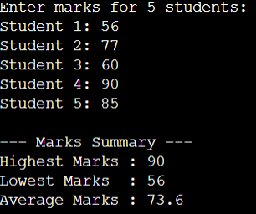

Topic 8: Function Inside the Class
22.INPUT
#include <iostream>
using namespace std;
class Calculator {
public:
double num1;
double num2;
void accept() {
cout << "Enter first number: ";
cin >> num1;
cout << "Enter second number: ";
cin >> num2;
}
void add() {
cout << num1 << " + " << num2 << " = " << (num1 + num2) << endl;
}
void subtract() {
cout << num1 << " - " << num2 << " = " << (num1 - num2) << endl;
}
void multiply() {
cout << num1 << " * " << num2 << " = " << (num1 * num2) << endl;
}
void divide() {
if (num2 != 0) {
cout << num1 << " / " << num2 << " = " << (num1 / num2) << endl;
} else {
cout << "Division by zero is not allowed." << endl;
}
}
};
int main() {
Calculator calc;
calc.accept();
cout << "\n--- Calculator Results ---" << endl;
calc.add();
calc.subtract();
calc.multiply();
calc.divide();
return 0;
}
- OUTPUT
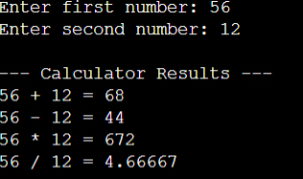
23.INPUT
#include <iostream>
using namespace std;
class Number {
public:
int num;
void accept() {
cout << "Enter an integer: ";
cin >> num;
}
void checkEvenOdd() {
if (num % 2 == 0) {
cout << num << " is even." << endl;
} else {
cout << num << " is odd." << endl;
}
}
};
int main() {
Number n;
n.accept();
n.checkEvenOdd();
return 0;
}
- OUTPUT
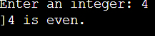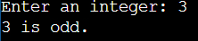
24.INPUT
#include <iostream>
#include <string>
using namespace std;
class Employee {
public:
string name;
double monthlySalary;
void accept() {
cout << "Enter employee name: ";
cin >> ws;
getline(cin, name);
cout << "Enter monthly salary: ";
cin >> monthlySalary;
}
void calculateAnnualSalary() {
double annualSalary = monthlySalary * 12;
cout << "\n--- Employee Details ---" << endl;
cout << "Name : " << name << endl;
cout << "Monthly Salary: $" << monthlySalary << endl;
cout << "Annual Salary : $" << annualSalary << endl;
}
};
int main() {
Employee emp;
emp.accept();
emp.calculateAnnualSalary();
return 0;
}
- OUTPUT
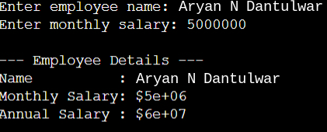

Topic 9: Function Outside the Class
25.INPUT
#include <iostream>
using namespace std;
class Rectangle {
public:
float length;
float breadth;
void accept();
float area();
};
void Rectangle::accept() {
cout << "Enter length: ";
cin >> length;
cout << "Enter breadth: ";
cin >> breadth;
}
float Rectangle::area() {
return length * breadth;
}
int main() {
Rectangle rect;
rect.accept();
cout << "Area of rectangle: " << rect.area() << endl;
return 0;
}
- OUTPUT
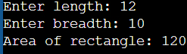
26.INPUT
#include <iostream>
using namespace std;
class Number {
public:
int n;
void accept();
long long calculateFactorial();
};
void Number::accept() {
cout << "Enter a positive integer: ";
cin >> n;
}
long long Number::calculateFactorial() {
if (n < 0) return -1;
long long fact = 1;
for (int i = 1; i <= n; i++) {
fact *= i;
}
return fact;
}
int main() {
Number num;
num.accept();
long long result = num.calculateFactorial();
if (result != -1) {
cout << "Factorial is: " << result << endl;
} else {
cout << "Factorial is not defined for negative numbers." << endl;
}
return 0;
}

- OUTPUT
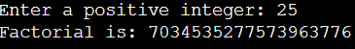
27.INPUT
#include <iostream>
using namespace std;
class Product {
public:
double price;
int quantity;
void accept();
double calculateTotalPrice();
};
void Product::accept() {
cout << "Enter unit price: ";
cin >> price;
cout << "Enter quantity: ";
cin >> quantity;
}
double Product::calculateTotalPrice() {
return price * quantity;
}
int main() {
Product prod;
prod.accept();
cout << "Total Price: " << prod.calculateTotalPrice() << endl;
return 0;}
- OUTPUT
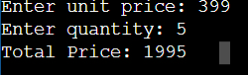

Topic 10: Access Specifiers
28.INPUT
#include <iostream>
using namespace std;
class Account {
private:
double balance;
public:
void setBalance(double b) {
if (b >= 0) {
balance = b;
} else {
cout << "Balance cannot be negative." << endl;
balance = 0;
}
}
double getBalance() {
return balance;
}
};
int main() {
Account acc;
double initialBalance;
cout << "Enter initial balance: ";
cin >> initialBalance;
acc.setBalance(initialBalance);
cout << "Current Balance: " << acc.getBalance() << endl;
return 0;
}
- OUTPUT
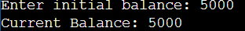
29.INPUT
#include <iostream>
using namespace std;
class AccessDemo {
private:
int privateVar;
public:
int publicVar;
void setPrivate(int val) {
privateVar = val;
}
int getPrivate() {
return privateVar;
}
};
int main() {
AccessDemo obj;
obj.publicVar = 50;
obj.setPrivate(100);
cout << "Public member accessed directly : " << obj.publicVar << endl;
cout << "Private member accessed via function: " << obj.getPrivate() << endl;
return 0;
}
- OUTPUT
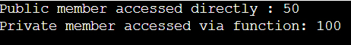
30.INPUT
#include <iostream>
using namespace std;
class BankAccount {
private:
double balance;
public:
BankAccount() {
balance = 0.0;
}
void deposit(double amount) {
if (amount > 0) {
balance += amount;
cout << "Successfully deposited $" << amount << endl;
} else {
cout << "Invalid deposit amount." << endl;
}
}
void withdraw(double amount) {
if (amount > 0 && amount <= balance) {
balance -= amount;
cout << "Successfully withdrew $" << amount << endl;
} else {
cout << "Invalid withdrawal amount or insufficient balance." << endl;
}
}
void displayBalance() {
cout << "Current Balance : $" << balance << endl;
}
};
int main() {
BankAccount myAccount;
myAccount.displayBalance();
myAccount.deposit(1000.0);
myAccount.withdraw(350.0);
myAccount.displayBalance();
return 0;
}
- OUTPUT
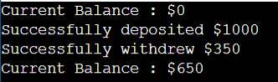

Topic 11: Default Constructor
31.INPUT
#include <iostream>
using namespace std;
class Rectangle {
private:
float length;
float breadth;
public:
Rectangle() {
length = 5.0;
breadth = 3.0;
}
void calculateArea() {
float area = length * breadth;
cout << "Length : " << length << endl;
cout << "Breadth: " << breadth << endl;
cout << "Area : " << area << endl;
}
};
int main() {
Rectangle rect;
rect.calculateArea();
return 0;
}

- OUTPUT
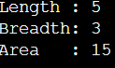
32.INPUT
#include <iostream>
#include <string>
using namespace std;
class Employee {
private:
string name;
int id;
double salary;
public:
Employee() {
name = "Aryan N Dantulwar";
id = 101;
salary = 50000.0;
}
void display() {
cout << "Name : " << name << endl;
cout << "ID : " << id << endl;
cout << "Salary : $" << salary << endl;
}
};
int main() {
Employee emp;
emp.display();
return 0;
}
- OUTPUT
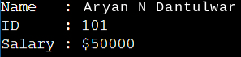
33.INPUT
#include <iostream>
using namespace std;
class BankAccount {
private:
double balance;
public:
BankAccount() {
balance = 10000.0;
}
void display() {
cout << "Account Balance: $" << balance << endl;
}
};
int main() {
BankAccount acc;
acc.display();
return 0;
}

- OUTPUT

Topic 12: Parameterized Constructor
34.INPUT
#include <iostream>
#include <string>
using namespace std;
class Student {
private:
int rollNo;
string name;
float marks;
public:
Student(int r, string n, float m) {
rollNo = r;
name = n;
marks = m;
}
void display() {
cout << "Roll No: " << rollNo << endl;
cout << "Name : " << name << endl;
cout << "Marks : " << marks << endl;
}
};
int main() {
Student s(101, "Alice", 88.5);
s.display();
return 0;
}
- OUTPUT
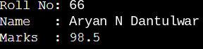
35.INPUT
#include <iostream>
using namespace std;
class Rectangle {
private:
float length;
float breadth;
public:
Rectangle(float l, float b) {
length = l;
breadth = b;
}
void calculateArea() {
float area = length * breadth;
cout << "Length : " << length << endl;
cout << "Breadth: " << breadth << endl;
cout << "Area : " << area << endl;
}
};
int main() {
Rectangle rect(6.5, 4.0);
rect.calculateArea();
return 0;
}
- OUTPUT
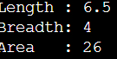
36.INPUT
#include <iostream>
using namespace std;
class Circle {
private:
float radius;
public:
Circle(float r) {
radius = r;
}
void display() {
cout << "Radius : " << radius << endl;
cout << "Area : " << (3.14159 * radius * radius) << endl;
}
};
int main() {
Circle c(5.5);
c.display();
return 0;
}
- OUTPUT
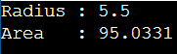

Topic 13: Single Inheritance
37.INPUT
#include <iostream>
using namespace std;
class Shape {
protected:
float length;
float breadth;
public:
Shape(float l, float b) {
length = l;
breadth = b;
}
};
class Rectangle : public Shape {
public:
Rectangle(float l, float b) : Shape(l, b) {}
void calculateArea() {
float area = length * breadth;
cout << "Length : " << length << endl;
cout << "Breadth: " << breadth << endl;
cout << "Area : " << area << endl;
}
};
int main() {
Rectangle rect(10.5, 4.2);
rect.calculateArea();
return 0;
}
- OUTPUT
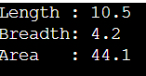
38.INPUT
#include <iostream>
using namespace std;
class Animal {
public:
void eat() {
cout << "Animal is eating..." << endl;
}
};
class Dog : public Animal {
public:
void bark() {
cout << "Dog is barking..." << endl;
}
};
int main() {
Dog myDog;
myDog.eat();
myDog.bark();
return 0;
}
- OUTPUT
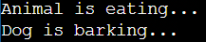
39.INPUT
#include <iostream>
#include <string>
using namespace std;
class Account {
protected:
string accountNumber;
double balance;
public:
Account(string accNo, double bal) {
accountNumber = accNo;
balance = bal;
}
};
class SavingsAccount : public Account {
private:
double interestRate;
public:
SavingsAccount(string accNo, double bal, double rate) : Account(accNo, bal) {
interestRate = rate;
}
void calculateInterest() {
double interest = (balance * interestRate) / 100.0;
cout << "Account Number : " << accountNumber << endl;
cout << "Current Balance: $" << balance << endl;
cout << "Interest Rate : " << interestRate << "%" << endl;
cout << "Earned Interest: $" << interest << endl;
}
};
int main() {
SavingsAccount savings("1234567", 10000.0, 5.0);
savings.calculateInterest();
return 0;
}
- OUTPUT
